### 

### **Technologic University of Aguascalientes**

Topic:

*“Interaction with git commands.”*

Student name:

Talamantes Castañeda Ángela María.

Enrollment:

191243.

Carrier/Classroom/Grade/Group:

IDGS ~ Aulas2, 9°A.

Teacher:

Alberto Campos Hernández.

Subject:

Comprehensive Web Integral.

Link:

<https://github.com/AngelaMTC/ExamenDiagn-sticoDWI>

* init

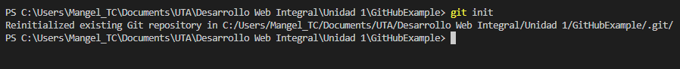

* status

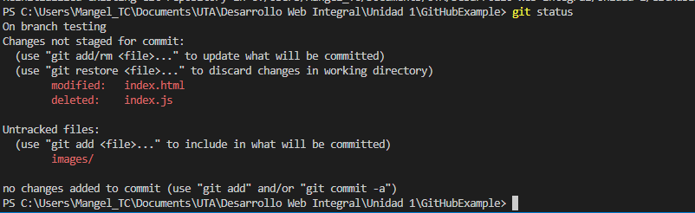

* add
* commit
* checkout
* merge
* diff
* push
* pull (de una rama a otra)
* remote add